Amazon RDS -
It is a relational database, RDS is fully managed fast and creditable performance.
RDS is simple and scalable.
RDS is low cost and pay for what we use.
Eg – MySql, Postgrace SQL, MariaDB, Oracle, Amazon Aurora
Amazon Aurora -
Is RDS reinvented for cloud, Aurora is 5 times better performance than MySql. It supports PostgreSQL and MySQL.
Aurora is available at 1/10 cost of commercial db.
RDS -
It is easy to administer, RDS is highly scalable.
RDS is available & durable.
RDS provides a feature called read replica.
Read Replica – Amazon RDS synchronously replicates the data to a standby instance in a different availability zone.
Amazon RDS supports most demanding applications and is fast.
It is made easy to control n/w access to your db.
Amazon RDS let you to run your database in your instance in VPC.
It isolates db and make it secure.

RDS Deployment types –
Read Replicas:
Read workload of your DB.
Can create up to 5 read Replicas.
Data is only written to the main DB.
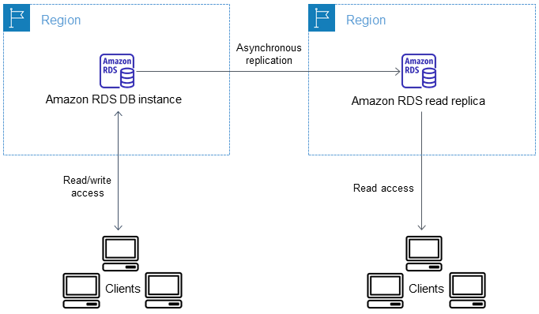

Multi – AZ:
Failover in case of AZ outage (high availability)
Data is only read/written to main database
Can only have 1 other AZ as failure.
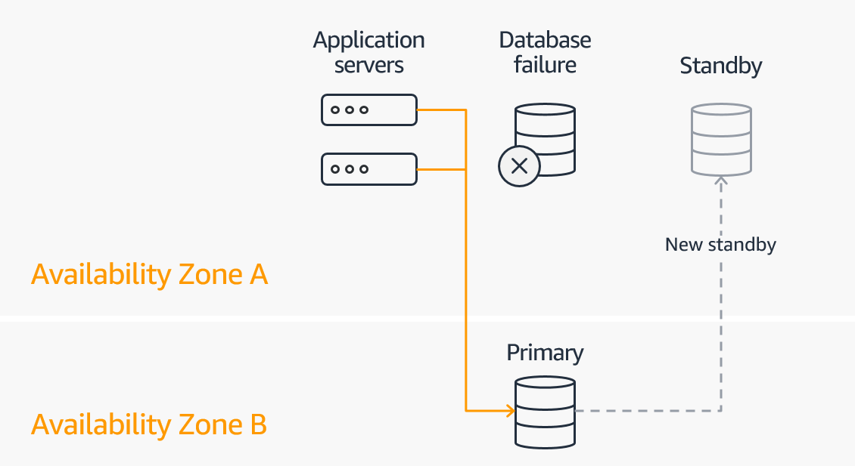
Dynamo DB -
DynamoDB is a fully managed, highly available database with replication across three availability zone.
It is part of the NoSQL database family, so it's not a relational database.
DynamoDB is one of the flagship product of AWS. It scales to massive workload and it's distributed serverless database, that means that we don't provision any servers.
With RDS or with ElastiCache, we need to provision a instance type, but with DynamoDB we don't. So it's called a serverless database.
Has low cost and auto scaling capabilities. A standard and infrequent access, IA, table class based on how you want to classify the data for cost saving.
Use cases -
Develop software applications - Build internet-scale applications supporting user-content metadata and caches that require high concurrency and connections for millions of users, and millions of requests per second.
Create media metadata stores - Scale throughput and concurrency for media and entertainment workloads such as real-time video streaming and interactive content, and deliver lower latency with multi-Region replication across AWS Regions.
Deliver seamless retail experiences - Use design patterns for deploying shopping carts, workflow engines, inventory tracking, and customer profiles. DynamoDB supports high-traffic, extreme-scaled events and can handle millions of queries per second.

What is Amazon RDS?
🔹 Simple Definition
Amazon RDS (Relational Database Service) is a managed database service that lets you create, operate, and scale relational databases in AWS without managing servers.
👉 AWS handles:
- Server setup
- OS patching
- Backups
- High availability
- Monitoring
👉 You focus on:
- Database schema
- Queries
- Application logic

🧠 One-Line Analogy
RDS is like a fully managed database hosted by AWS, where you don’t worry about infrastructure.

🗄️ Databases Supported by RDS
Database Engine
MySQL
PostgreSQL
MariaDB
Oracle
SQL Server
Amazon Aurora

⚙️ What AWS Manages for You
Task | Handled by AWS
Hardware | ✅
OS installation | ✅
Database installation | ✅
Patching | ✅
Backups | ✅
Failover | ✅
Monitoring | ✅

🧩 What YOU Manage
Task | Your Responsibility
Table creation | ✅
SQL queries | ✅
Indexes | ✅
Users (DB level) | ✅
Application logic | ✅

🏗️ RDS Architecture (Easy to Understand)
- RDS runs inside a VPC
- Deployed in private subnets
- Accessed using an endpoint
- Secured using security groups
👉 You connect using:
endpoint + port + username + password

🔁 High Availability (Multi-AZ)
What is Multi-AZ?
- Primary DB in one AZ
- Standby DB in another AZ
- Automatic failover
✔ No data loss
✔ No manual intervention

📖 Read Replicas (Scaling Reads)
- Used for read-heavy applications
- Replicates data from primary DB
- Improves performance
Example:
- Writes → Primary
- Reads → Replica

🔐 Security in RDS
- Runs in private subnet
- Controlled via security groups
- Encryption at rest & in transit
- IAM + Secrets Manager (advanced)

🧠 Real-World Scenario
E-commerce Application
- Backend app on EC2
- MySQL database on RDS
- Multi-AZ enabled
- Read replicas for reports
Result:
- High availability
- Scalable
- Secure

❌ RDS vs EC2 MySQL (Important Interview Question)
Feature | RDS | MySQL on EC2
Setup | Automatic | Manual
Backups | Automatic | Manual
HA | Built-in | Custom
Patching | Automatic | Manual
Scaling | Easy | Hard
📌 RDS is preferred for production

🔥 Key RDS Features (Memorize)
- Automated backups
- Snapshots
- Multi-AZ
- Read replicas
- Monitoring via CloudWatch
- Maintenance windows

🎤 Interview One-Line Answer
Amazon RDS is a managed relational database service that simplifies database setup, maintenance, backups, scaling, and high availability.

🎯 Interview Question Example
Q: Why would you choose RDS over MySQL on EC2?
RDS reduces operational overhead by managing backups, patching, monitoring, and high availability, allowing teams to focus on application development.

